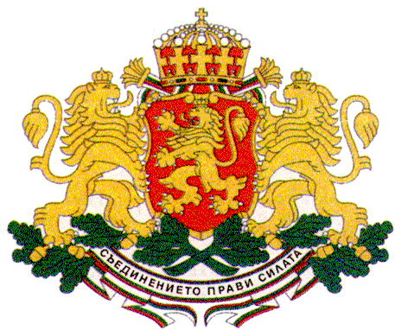 | PERMANENT MISSION OF THE REPUBLIC OF  BULGARIA  TO THE UNITED NATIONS
11 East 84th Street, New York, NY 10028, Tel: (212) 737 4790, Fax: (212) 472 9865, e-mail: bulgaria@un.int

United Nations General Assembly 70th Session, Third Committee
New York, October – November 2015 (CR 1 CB)

General Debate
Agenda Item 68 (a, b): Promotion and Protection of the Rights of Children

H.E. Mr. Stephan Tafrov, Ambassador,
Permanent Representative of Bulgaria to the UN

New York, 16 October 2015

Mr. Chair,
Bulgaria aligns itself with the statement made by the European Union on this agenda item. I would like to share some remarks in my national capacity.
The recent adoption of the new 2030 Agenda for Sustainable Development is a crucial step forward in the efforts of the international community to pave the way for building a better world in the next fifteen years for all people and especially for children.
During the negotiations Bulgaria has advocated strongly, including as a co-chair of the Group of Friends of Children and SDGs, for integrating children’s human rights in all aspects of development with the aim to put children at the heart of the new framework. The 2030 agenda is truly transformative as it was designed for the people envisaging children and youth as the real agents of change.
My country participated actively also in the UNICEF global initiative the “World’s Largest Lesson” aimed at teaching children about the Sustainable Development Goals. Bulgaria believes this initiative, which mobilized nearly 500 million girls and boys between the ages of 8 to 14 in over 100 countries, including more than 17 000 Bulgarian students, can become a powerful movement to engage children in the joint effort to achieve the new goals by encouraging them to drive real change in their own lives. We are grateful to the Executive Director of UNICEF Mr. Anthony Lake and his team for this important initiative.

Mr. Chair,
The world today confronts the largest humanitarian crisis since the Second World War which affects children adversely. The mass migration that we are experiencing is of an unprecedented scale and nature and requires immediate action through a coherent and comprehensive international response. I would like to emphasize children’s particular vulnerability in this situation. We are appalled at the shocking images of children forced into migration in the quest for better life that we see in the media every day. It is our moral duty and responsibility as humans to relieve the plight of children by all means urgently.
Being a transit and a host country of thousands of migrants and refugees Bulgaria is making every effort, in cooperation with the EU, UNICEF and other partners, to ensure good living conditions for all those fleeing from the scourge of war and seeking refuge by paying particular attention to the specific needs of migrant children, especially unaccompanied children seeking help, through the provision of essential services such as food, healthcare, education, etc.
Mr. Chair,
The protection of children is a key priority for Bulgaria. The Bulgarian Government undertakes sustained and coordinated measures for promoting the human rights and well-being of all children. Special attention is paid to the social inclusion of children and the protection of the right of every child to grow up in a family environment through a number of targeted policies aimed at encouraging good parenting and supporting families with children, promoting innovative integrated services for early childhood development and ensuring better access to child care centers, quality education and advanced healthcare services for small children. Significant progress has been achieved in the process of deinstitutionalization, including through the implementation of special measures for the prevention of child abandonment and the provision of foster care and social services in the community.
Bulgaria attaches great importance also to the promotion of inclusive education and takes the necessary measures for ensuring equal access to quality education for all, including children and youth with special needs.
Mr. Chair,
Ending violence against children is of crucial importance for protecting children’s rights. The Bulgarian Government works closely with UNICEF, media and other partners on a number of social campaigns, including “End Violence”, “Making the Invisible Visible”, “Imagine”, etc., in order to raise awareness in the society about the scope of the problem and bring to justice the perpetrators.
In March 2015 UNICEF Bulgaria launched a social campaign for promoting the right of child participation with the aim to encourage an informed inclusion of children of different ages, social status and ethnic background in all processes that affect their lives. The first ever direct online consultation with children entitled “My Voice Matters” was conducted as part of the campaign and covered topics of great public concern such as education, healthcare, social security, violence, etc.
The results of this consultation with children will be taken into consideration by the National Assembly of Bulgaria, the Council of Ministers and the State Agency for Child Protection when updating the National Strategy for the Child.
Mr. Chair,
Bulgaria remains fully committed to the further advancement of the human rights of children in all its policies and activities both domestically and globally.

Thank you, Mr. Chair.

